WEB PUBLISHING SYSTEM

**Sidekick of Semester (SOS)**

**Prepared By**

**Abhishek Singhal**



**MEERUT INSTITUTE OF ENGINEERING & TECHNOLOGY, MEERUT**

**Affiliated to**

**Dr. APJ ABDUL KALAM UNIVERSITY**

**Version 0.1 (DRAFT)**

**© MEERUT INSTITUTE OF ENGINEERING & TECHNOLOGY, MEERUT**

All rights reserved. No part of this publication may be reprinted, reproduced, stored in a retrieval system or transmitted, in any form or by any means, without the prior permission in writing from the owners.

|  |  |
| --- | --- |
| Status | Draft |
| Client Deliverable Item | Yes |
| Configuration Item | Yes |
| Distribution | 1. ----------------------- |
|  | 2. ---------------------- |
|  |  |

# Revision History

|  |  |  |  |
| --- | --- | --- | --- |
| **Version** | **Date** | **Change Description** | **Author** |
| 0.1 | __October, 2021 | Created | Dr. Tanveer |
| 0.2 | __November,2021 |  |  |
|  |  |  |  |
|  |  |  |  |

|  |  |
| --- | --- |
| **INTERNAL USE ONLY:** |  |
| **Contributors:** |  |
| **Prof.Tanveer Ikram** | **Subject Expert** |
| **Mr. XYZ** | **Subject Expert** |
|  |  |
|  |  |
|  |  |
| **Created By:** | **Reviewed By Project Guide:** |
| **Name 1** |  |
| **Name 2** |  |
| **Name 3** |  |
| **_____________________________** | **_____________________________** |
| Name: | Name: |
| Designation: | Designation: |
| Department: | Department: |
| Date: | Date: |
|  |  |
|  |  |
|  |  |
|  |  |
| **Reviewed By Project Head:** | **Approved By HOD:** |
|  |  |
|  |  |
|  |  |
| **_____________________________** | **_____________________________** |
| Name: | Name: |
| Designation: | Designation: |
| Department: | Department: |
| Date: | Date: |

**Content**

1. **Problem Statement-------------------------------------------------**
2. **Speciality of Website**
3. **Home Page**
   1. Features
   2. Helps in
   3. Links
4. **Notes**
5. **Lecture**
6. **Test**
   1. Algorithm
   2. Speciality of Test
7. **Coding**
8. **About us**
   1. Speciality of About us
9. **Problem Statement**

B.tech is of 4year having 8semester exam and the most of our time is wasted in managing notes as well finding them in of messy phone and laptop.

So, This SOS (Sidekick of semester) saves your most of the time. As here you will get all of the notes for your subject.

Sidekick means helper,

And whole Sidekick of Semester means helper of semester

1. **Speciality of Website**

* This website can run on any of the device it doesn’t matter what is the size of the device. This website is fully responsive.
* This website run on each and every Browser without any problem.
* This website was built by using HTML5, CSS, JavaScript, Bootstrap(A framework for CSS), Font Awesome(use for icons in my website), 'Yaldevi' as the font used in my website taken from Google fonts which enhance the beauty of my website.
* My website Contain 7 Webpages , 5 CSS file to easy my work, And 2 JavaScript file. All the images & Videos are taken from Unsplash.com
* Every page of the website is divided into 3 parts:
  + Header
  + Main
  + Footer.

1. **Home Page**

* It was the main page of my website.
* From this page you can navigate to another page of the website.
* Main part of this page contain 3 columns.
* Features
* Helps in
* Links
  1. FEATURES
* NOTES:
* All 8 semesters notes were provided here unit wise.
* Which definitely helps in boosting your marks.
* MCQ:
* We will provide you MCQ of all the subjects.
* QUESTION PAPER:
* We will try to give you all the previous year question paper.
* TEST:
* A MCQ based test which helps you in practicing of your subject.
* CODING
* We will give you a knowledge about Coding by which you can improve your coding skills.
* LECTURES
* We will try to give you all the Video lectures for your subject.
* This will help you in learning you topics.
  1. HELPS IN
* TIME SAVER
* You didn’t want to search notes you get them on one place.
* Got best of the lecture on one place.
* CARRIER MAKER
* You will improve your coding by this site.
* CONFIDENCE BUILD
* Improve confidence by giving test
  1. LINKS
* You will get our social media links by which you can follow us and get updated.

1. **Notes**

* On webpage you will get so many button in button the name of the subject and its subject code is written.
* By clicking on a button you will divert to another page i.e. of drive.
* On this page you will get all 5unit notes.
* Also a folder having MCQs.
* Notes were written by experienced teachers of MIET.

1. **Lectures**

* This page contain so many sections and each section have is name i.e. of subject name.
* Under each section we have provided you lectures taken from YouTube.
* Videos is of experienced teachers who helps you in boosting your knowledge.

1. **Test**

This page contain test which helps you in your training.

* 1. ALGORITHMS:

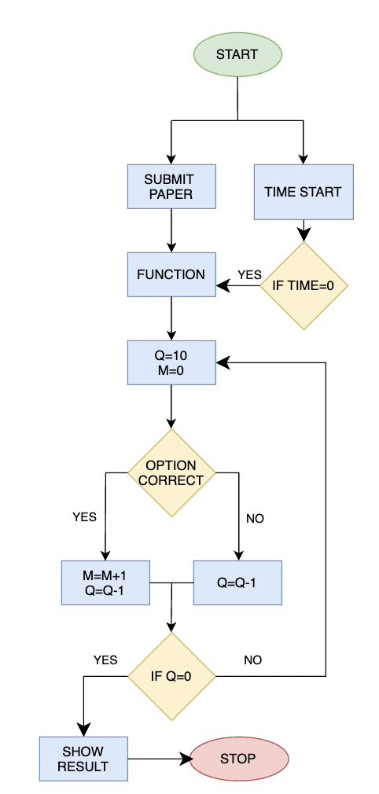

* 1. SPECIALITY OF TEST
* As per security purpose right click on this website is off.
* There was a time limit to make test secure.
* You have to choose all option before submit.
* It will show pass if candidate score more than 5marks.

1. **Coding**

In this we will discuss about:-

* What is Coding
  + Tells about how Coding to working.
* How Coding works
  + Tells how Coding works.
* Is Learning to code Difficult
  + Tells how to make Coding easy.
* Popular Coding Languages to learn.
  + Here we will discuss about different type of language, And how to learn it very easily.

1. **About us**

* Tells about my website.
* Having contact us form which sends an feedback to the Excel on my drive
* Also having a map showing location.

1. **Bibliography**

* All images and videos from [unspash](https://unsplash.com/).
* Icons from [Font Awesome.](https://fontawesome.com/v5.15/icons?d=gallery&p=2)
* Font from [Google Fonts](https://fonts.google.com/).
* CSS framework [Bootstrap.](https://getbootstrap.com/)

**WEBSITE LINK** [**https://abhimrt.github.io/Sos/**](https://abhimrt.github.io/Sos/)

**WEBSITE REPOSETARY** [**https://github.com/Abhimrt/Sos**](https://github.com/Abhimrt/Sos)